SCHOOL MANAGEMENT SYSTEM
(Console Based Application)
Project By: PUNIT
Project Type: Academic / Mini Project
Platform: C / C++ (Console Application)
Interface: Text-based (CLI)

1. INTRODUCTION
The School Management System is a console-based application designed to manage and organize school-related data efficiently.
This system provides three different user roles:
- Admin
- Teacher
- Student
Each role has specific access rights and features to ensure secure and structured management of school records such as teacher data, student data, and academic marks.

2. OBJECTIVES OF THE PROJECT
- To manage student records efficiently
- To allow teachers to maintain and update student data
- To give admin full control over the system
- To provide role-based access
- To ensure data integrity and easy retrieval
- To simulate a real-world school management workflow using a console interface

3. SYSTEM FEATURES OVERVIEW
Role | Key Features
Admin | Full system control
Teacher | Manage students of assigned class
Student | View personal details & marks

4. MAIN MENU / MAIN PANEL
This is the first screen displayed when the program starts.
Main Menu Options:
1. Enter as Teacher
2. Enter as Student
3. Enter as Admin
4. Exit
Each option redirects the user to their respective module.
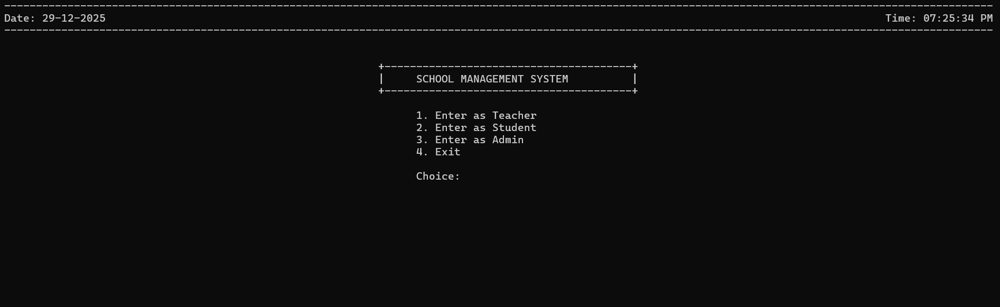

5. TEACHER MODULE
5.1 Teacher Entry Menu
1. Teacher Signup
2. Teacher Login
3. Back
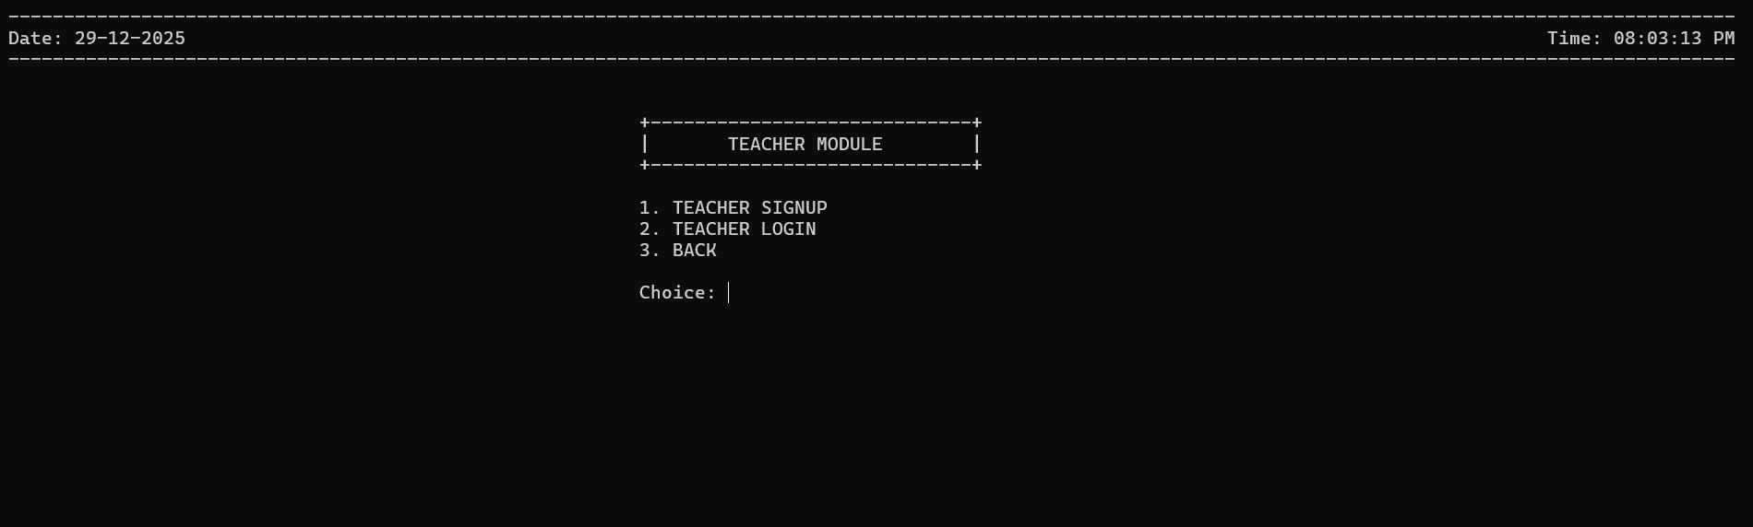

5.2 Teacher Signup Page
This allows new teachers to register into the system.
Required Fields:
- Name
- Teacher ID
- Class Assigned
- Password
Output:
- Successful registration confirmation
- Option to add another teacher
✔ Data is stored for future login authentication.
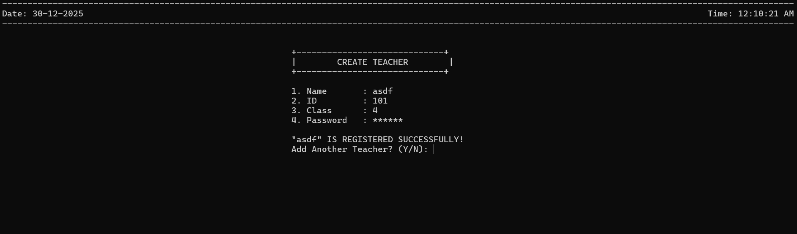

5.3 Teacher Login Page
Registered teachers can log in using:
- Name
- ID
- Class
- Password
On Success:
[SUCCESS] Login Verified!

5.4 Teacher Panel
Once logged in, the teacher can manage student data of their assigned class.
Teacher Panel Options:
1. Student Entry
2. Student Search
3. Update Student
4. Delete Student
5. Display All Students
6. Exit
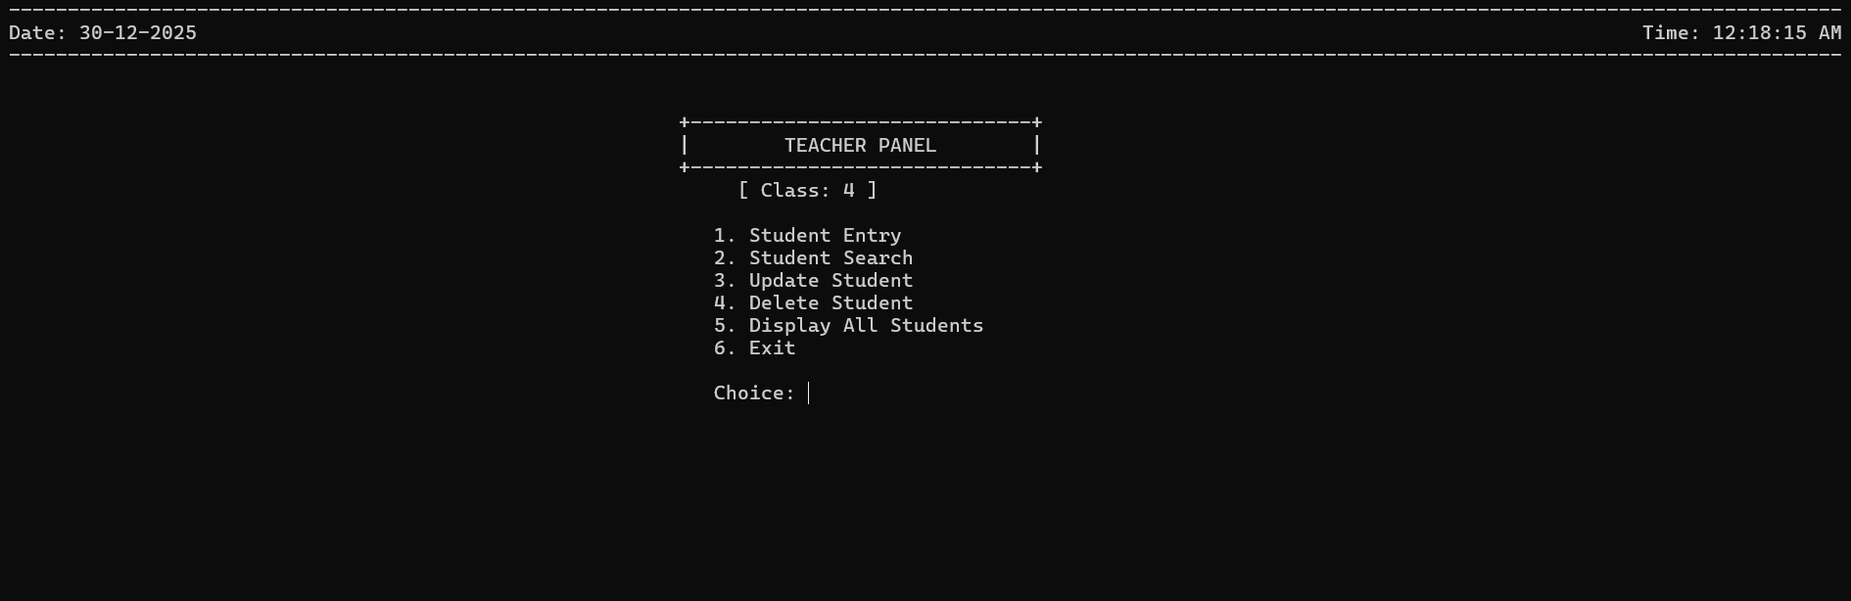

5.5 Teacher Functionalities Explained
- Student Entry: Add new student details and marks
- Student Search: Search student using roll number
- Update Student: Modify student personal data or marks
- Delete Student: Remove student records
- Display All Students: View all students of the class
- Exit: Logout from teacher panel

6. STUDENT MODULE
6.1 Student Access
Students access the system after selecting Enter as Student and providing:
- Name
- Roll Number
- Class
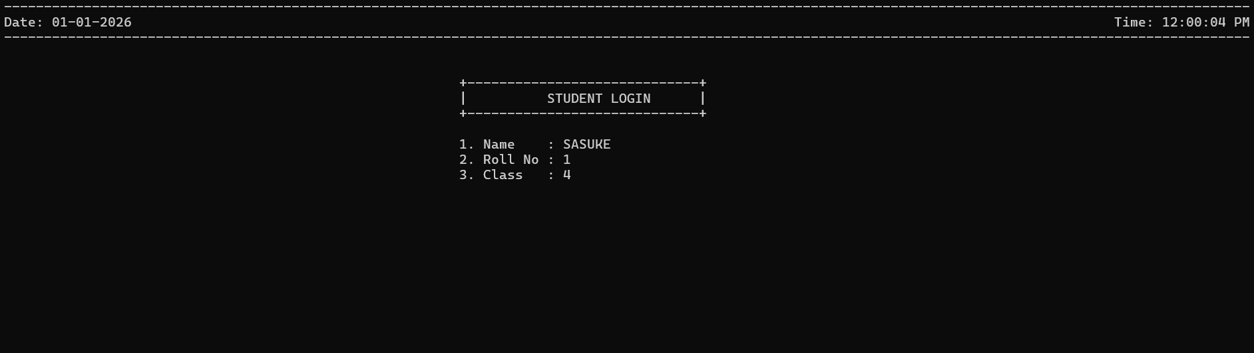

6.2 Student Panel
1. View My Details & Marks
2. Logout
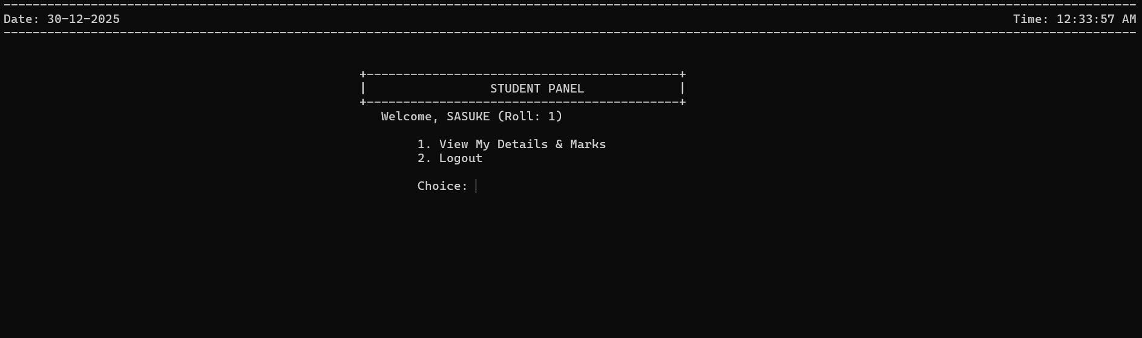

6.3 Student Profile Page
Students can view:
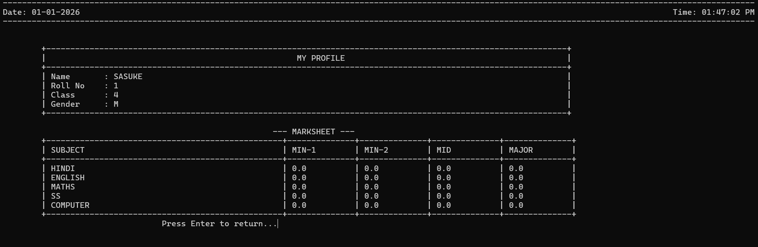
✔ Students have read-only access.

7. ADMIN MODULE
7.1 Admin Login Page
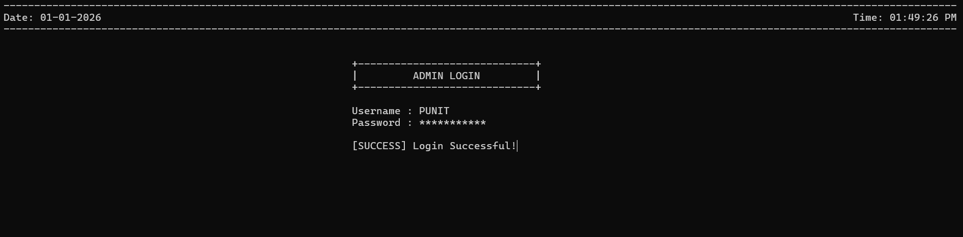
Admin access is protected by predefined credentials.
Credentials Required:
- Username
- Password
On Success:
[SUCCESS] Login Successful!

7.2 Admin Dashboard
Admin has full control over the entire system.
Admin Menu Options:
1. Create Teacher Entry
2. Enter as Teacher (Test)
3. Update Teacher
4. Create Student
5. Update Student
6. Search All Students
7. Display All Teachers
8. Search a Student
9. Logout
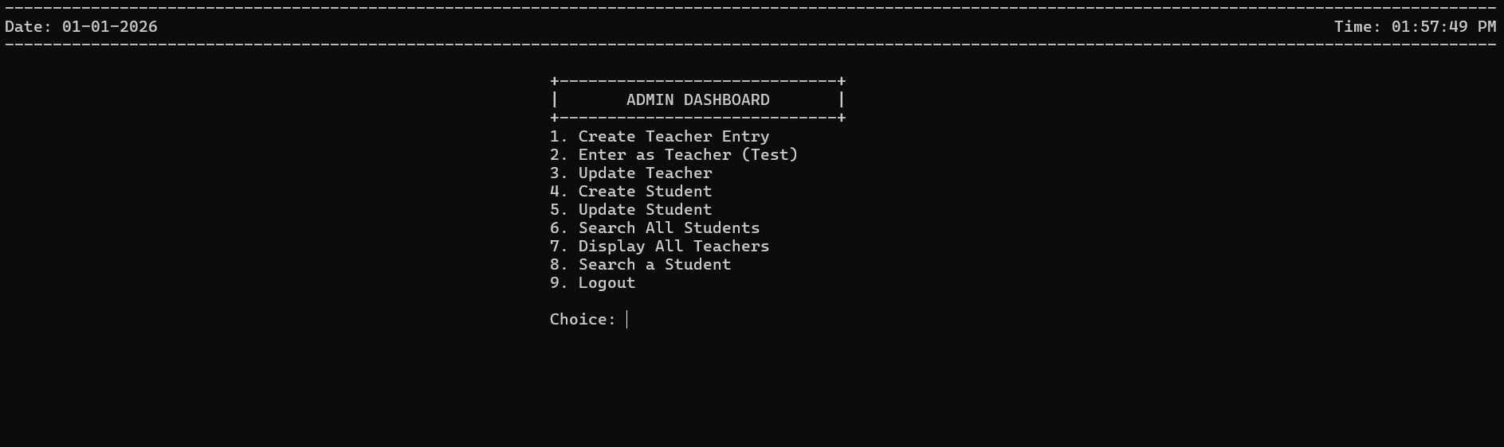

7.3 Admin Capabilities
- Add / update teachers
- Add / update students
- View all records
- Search any student
- Monitor system activities
- Manage entire database

8. DATA MANAGEMENT
- Data is stored using file handling
- Separate records for:
  - Teachers
  - Students
- Data is persistent across program runs

9. SECURITY FEATURES
- Role-based access control
- Password-protected admin and teacher login
- Students cannot modify data
- Admin credentials are predefined

10. LIMITATIONS
- Console-based UI
- No encryption for stored passwords
- No database (file handling only)
- Single-user execution

11. FUTURE ENHANCEMENTS
- GUI-based interface
- Database integration (MySQL)
- Password encryption
- Attendance management
- Fee management system
- Parent login module
- Online portal integration

12. CONCLUSION
The School Management System successfully demonstrates how a real-world school environment can be managed digitally using a structured, role-based approach.
This project is ideal for understanding file handling, menu-driven programs, and system design concepts in programming.

